EMPLOYEE BENEFITS (GPF/ ESI SCHEME, NPS, SERVICE GRATUITY, FACULTY IMPROVEMENT
- GPF (General Provident Fund), NPS and ESI scheme
As per the existing norms of Central Government, GPF (General Provident Fund), NPS and ESI schemes are implemented for the teaching, non-teaching and contingent staff. See http://www.finhry.gov.in/Portals/0/hcs-gpf-rules-2016_1.pdf
- SERVICE GRATUITY
How Gratuity calculated: The formula is: (15 * your last drawn salary * the working tenure) / 30. For example, you have a basic salary of Rs 30,000. You have rendered continuous service of 7 years and the employer is not covered under the Gratuity Act. Gratuity Amount = (15 * 30,000 * 7) / 30 = Rs 1, 05,000.
- LEAVE FOR STAFF MEMBERS
- A member of the staff on casual leave is not treated as absent from duty and his pay is not interrupted. The maximum numbers of casual leaves in a calendar year are 20 after completion of service 20 years.
- Casual leave cannot be combined with any other kind of leave.
- Balance casual leaves will not be converted into earned leaves.
- EARNED LEAVES
- The teaching staff of the college will be eligible for annual leave / earned leave 10 days for a year maximum 300 day’s encashed at the retirement for teaching staff.
- The earned leaves can be availed during the academic period as applicable without causing any academic disturbance and should be recommended by Principal.
- STUDY LEAVE
The scheme of Study Leave provides an opportunity to avail of scholarships / fellowships awarded to the faculty who wish to acquire new knowledge and to improve analytical skills. When a teacher is awarded a scholarship or stipend (by whatever nomenclature used) for pursuing further studies leading to Ph. D / Post doctoral qualification or for undertaking research project in a higher education institution abroad, the amount of the scholarship/ fellowship shall not be linked to the recipient's pay / salary paid to her / him by his / her parent institution. The awardees shall be paid salary for the entire duration of fellowship scholarship, provided of course s/he does not take up any other remunerative jobs like teaching, in the host country.

- MATERNITY LEAVE/ PATERNITY LEAVE
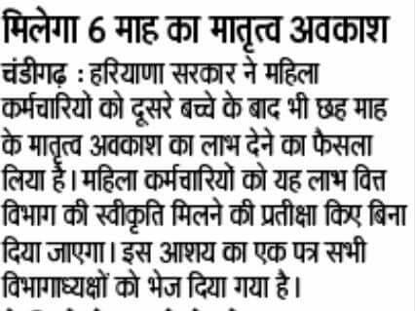

Third child maternity leaves- Haryana Govt. allow the maternity leave for 3rd child to women employee vide finance department letter no. 11/16/89-3FR-II dated 20.05.2016. Court case regarding third child maternity leave was Supreme Court case Javed and others vs State of Haryana and others (2003)8SCC 369 and Air India and others vs Nergesh Meerza and others (1981) 4SCC335. The high court allowed CWP No. 4229 of 2011 Ruksana vs the State of Haryana by holding the petitioner is entitled to the payment of salary as maternity leave benefit as envisaged under section 5 of the maternity benefit read with rule 8.124 of Punjab CSR volume I part I without making any reference to note 4 appended there under.
Also see- Leave rules in Haryana, Contract employee maternity leave,
- SUMMER VACATION
Long summer vacation shall be given to the entire teaching staff as Kurukshetra University, Kurukshetra rule nearly 1.5 months.
- Faculty Improvement Programmes
- Faculty members are permitted to improve their academic qualification by attending courses/ research work in higher educational institutions of learning.
- Staff is encouraged to attend conferences / workshops / Faculty Development Programmes and training programmes every year.
- Sponsorships to attend and present papers in conferences in India.
- All the faculty members who upgrade their research work through quality publications during the academic year are honored by Principal with non – financial motivation.
- Faculty development programs (FDP) for faculty members on regular basis.
- Other Benefits
- College provides financial support for teaching and non-teaching staff as per Government rules.
- The Government provides effective welfare measures and also delivers soft loans to the staff.
- Gym is freely accessible for the staff.
- Internet and free Wi-Fi facilities are also available in campus for staff.
- The support staffs are provided with two pairs of uniform and interest free loan in support for their needs.

